# ****Network Devices Lab Documentation****

## ****Objective****

This lab aims to familiarize you with configuring basic network devices, such as routers and switches, and establishing connectivity between two different subnets. By the end of this lab, you will understand how to:

* Configure router interfaces.
* Set up IP addressing on PCs.
* Verify connectivity between different networks using basic commands.

## ****Step-by-Step Lab Documentation****

### ****Step 1: Preparing the Network Topology****

**Add the following devices** in your network simulation tool (e.g., Cisco Packet Tracer):

**1 Router**

**2 Switches**

**3 PCs (PC1, PC2, PC3)**

**Connect the devices** using Ethernet cables:

* Connect **Router GigabitEthernet0/0** to **Switch 1**.
* Connect **Router GigabitEthernet0/1** to **Switch 2**.
* Connect **PC1 and PC2** to **Switch 1**.
* Connect **PC3** to **Switch 2**.

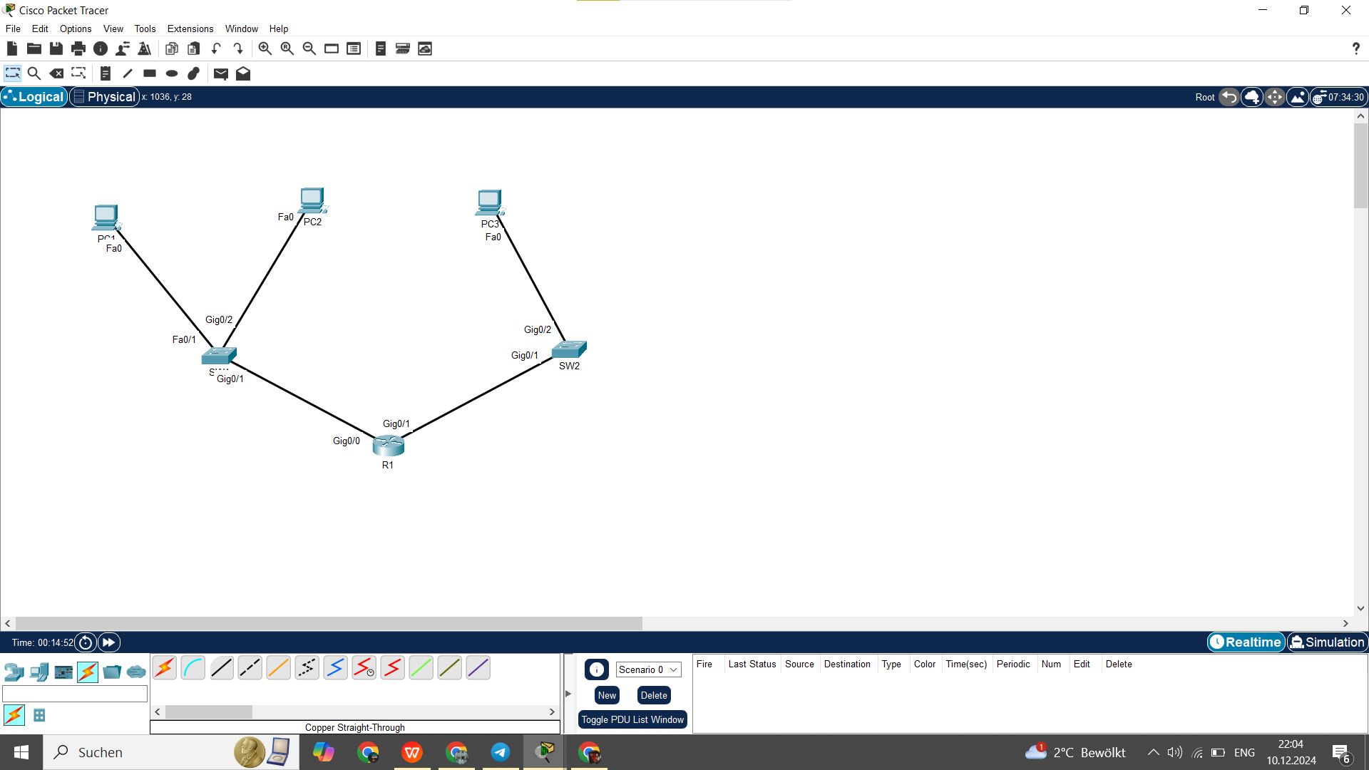

### ****Step 2: Assigning IP Addresses to PCs****

**PC1 Configuration** (Subnet: 192.168.1.0/24):

* 1. **IP Address:** 192.168.1.1
  2. **Subnet Mask:** 255.255.255.0
  3. **Default Gateway:** 192.168.1.254

**PC2 Configuration** (Subnet: 192.168.1.0/24):

* 1. **IP Address:** 192.168.1.2
  2. **Subnet Mask:** 255.255.255.0
  3. **Default Gateway:** 192.168.1.254

**PC3 Configuration** (Subnet: 192.168.2.0/24):

* 1. **IP Address:** 192.168.2.1
  2. **Subnet Mask:** 255.255.255.0
  3. **Default Gateway:** 192.168.2.254

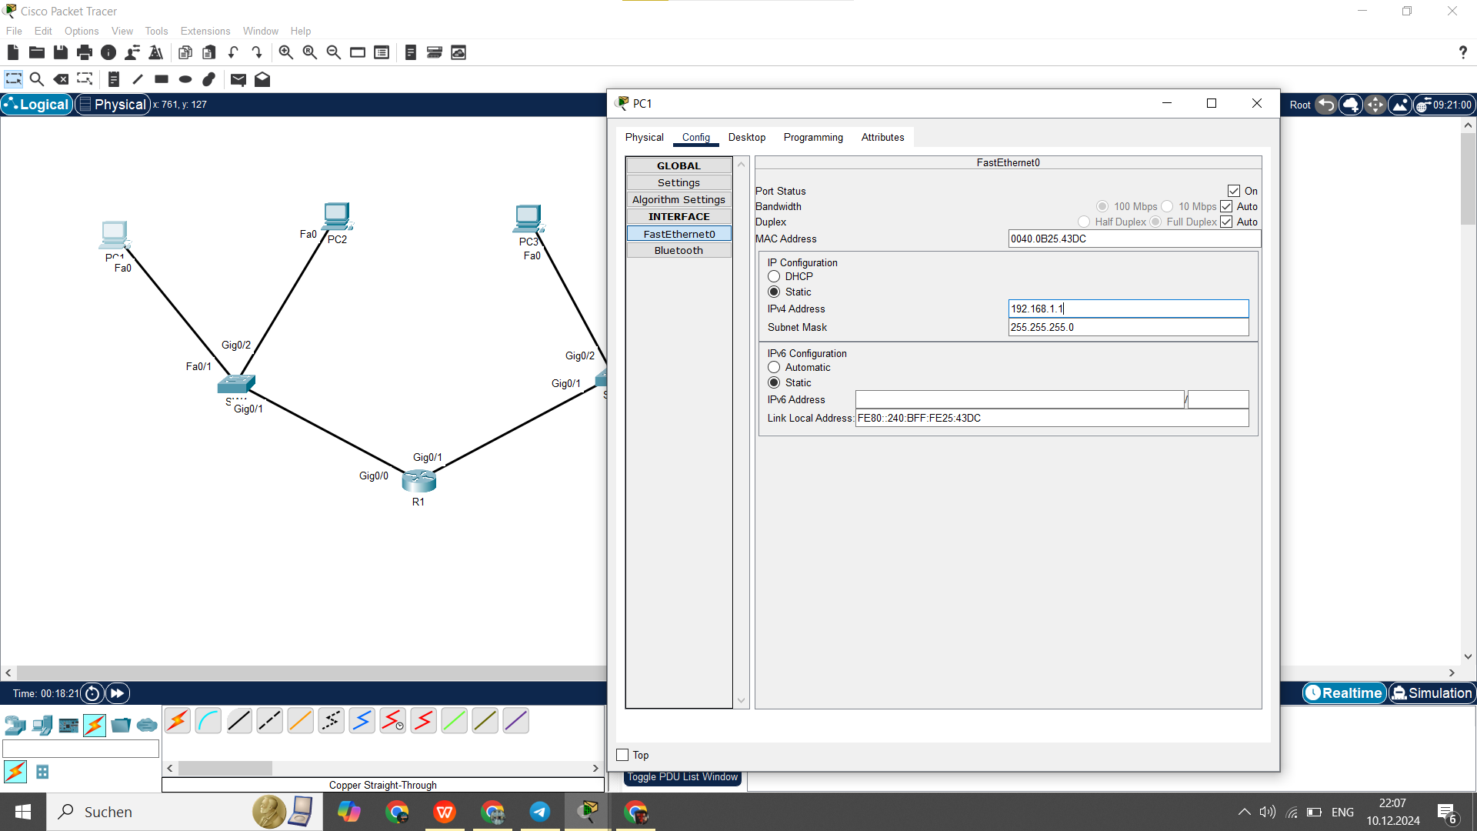

**Default gateway:**

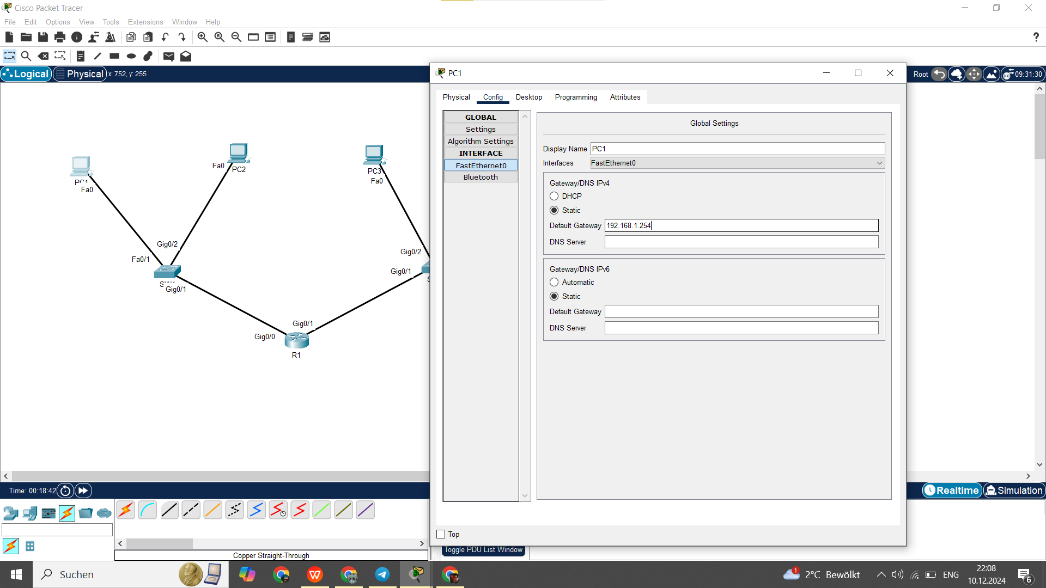

**Step 3 Config R1 and saving configuration:**

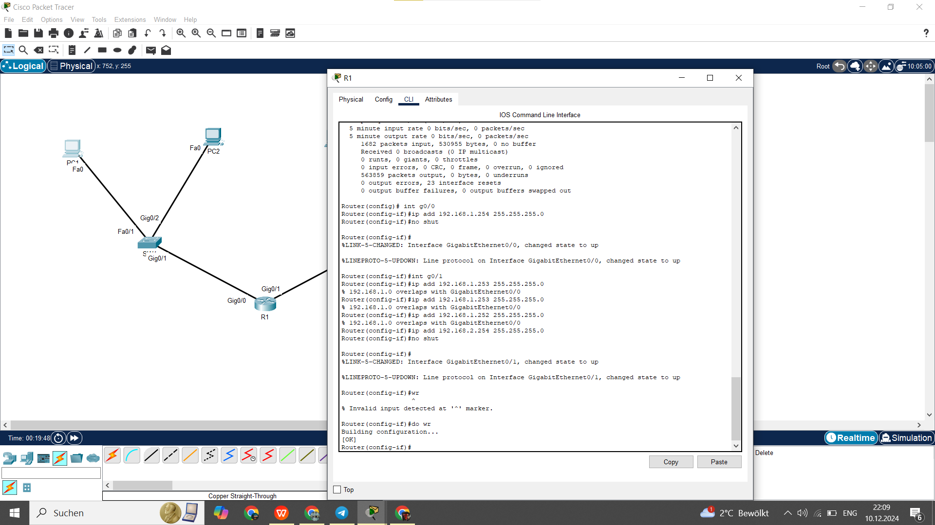

### ****Step 4: Verifying Connectivity****

PC1:

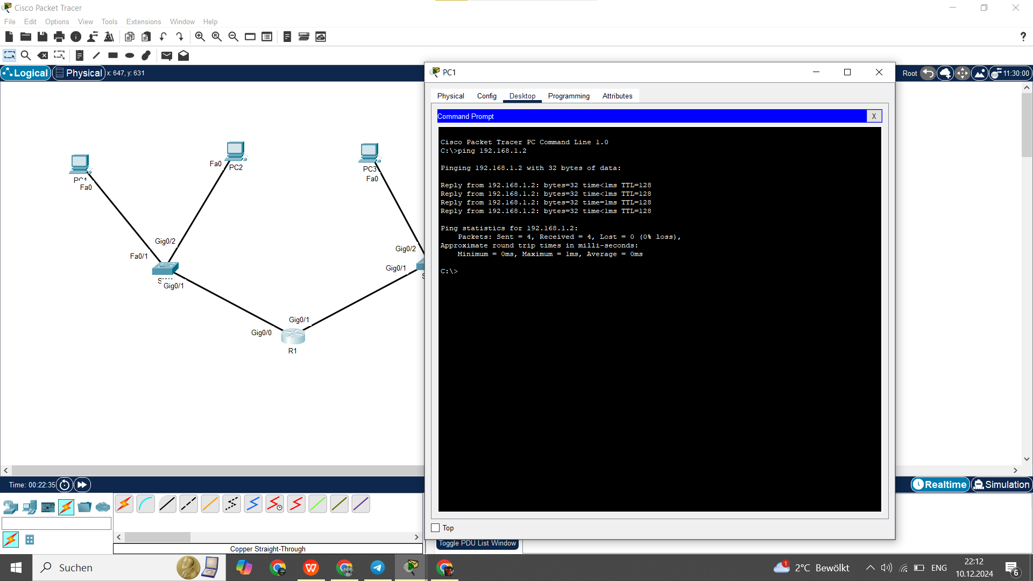

PC2:

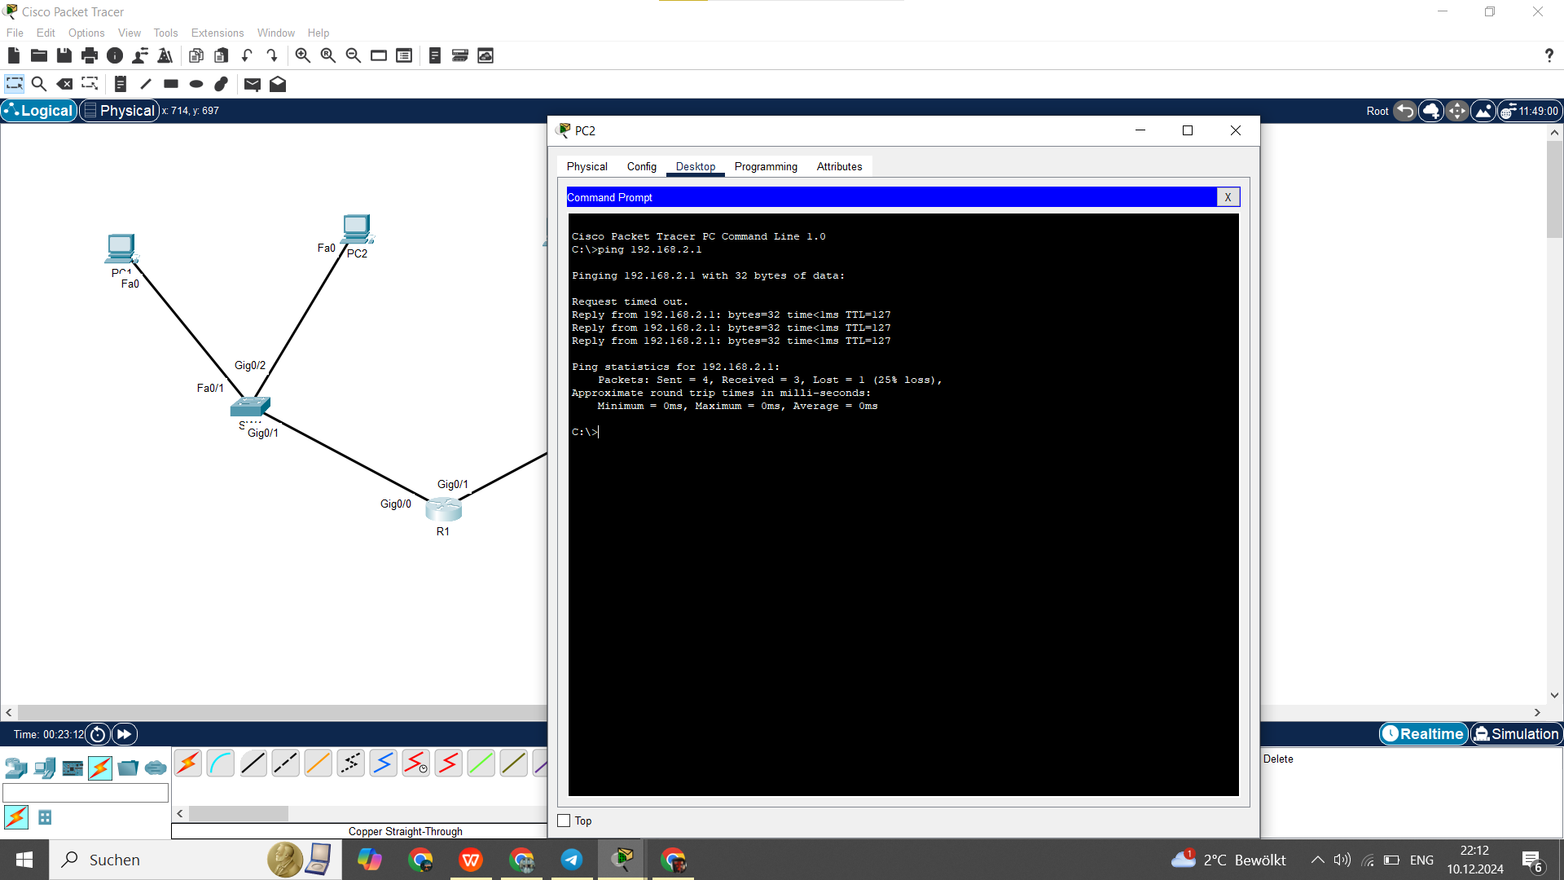

### ****Step 5: Troubleshooting (If Needed)****

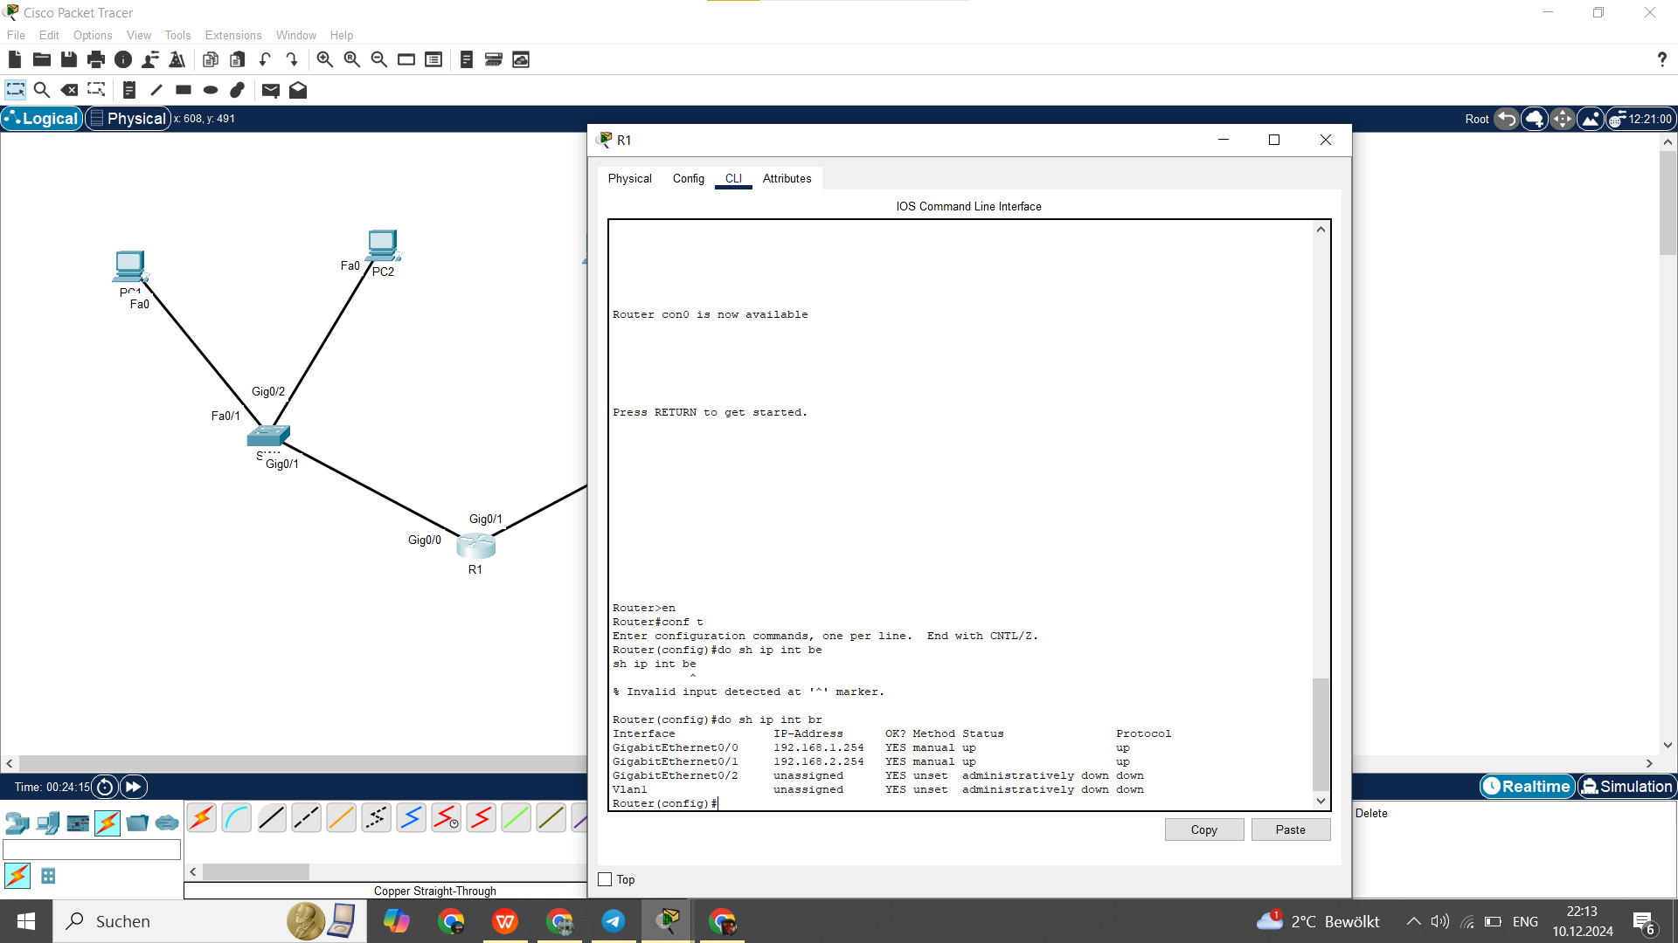

**Check Router Interface Status**:

Ensure the interfaces are **up** and have the correct IP addresses.

**Verify PC IP Settings**:

Check that each PC has the correct **IP address**, **subnet mask**, and **default gateway**.

**Check Cable Connections**:Ensure all devices are correctly connected in the topology.

### ****Conclusion****

In this lab, we configured basic network devices, including routers, switches, and PCs, and established connectivity between two subnets. The tasks included:

* **IP addressing and subnet configuration** on PCs.
* **Router interface configuration** for inter-subnet communication.
* **Ping tests** to verify successful connectivity between devices.

By completing this exercise, we reinforced key networking concepts such as IP addressing, router configuration, and troubleshooting, all of which are fundamental for the **CCNA 200-301** certification.